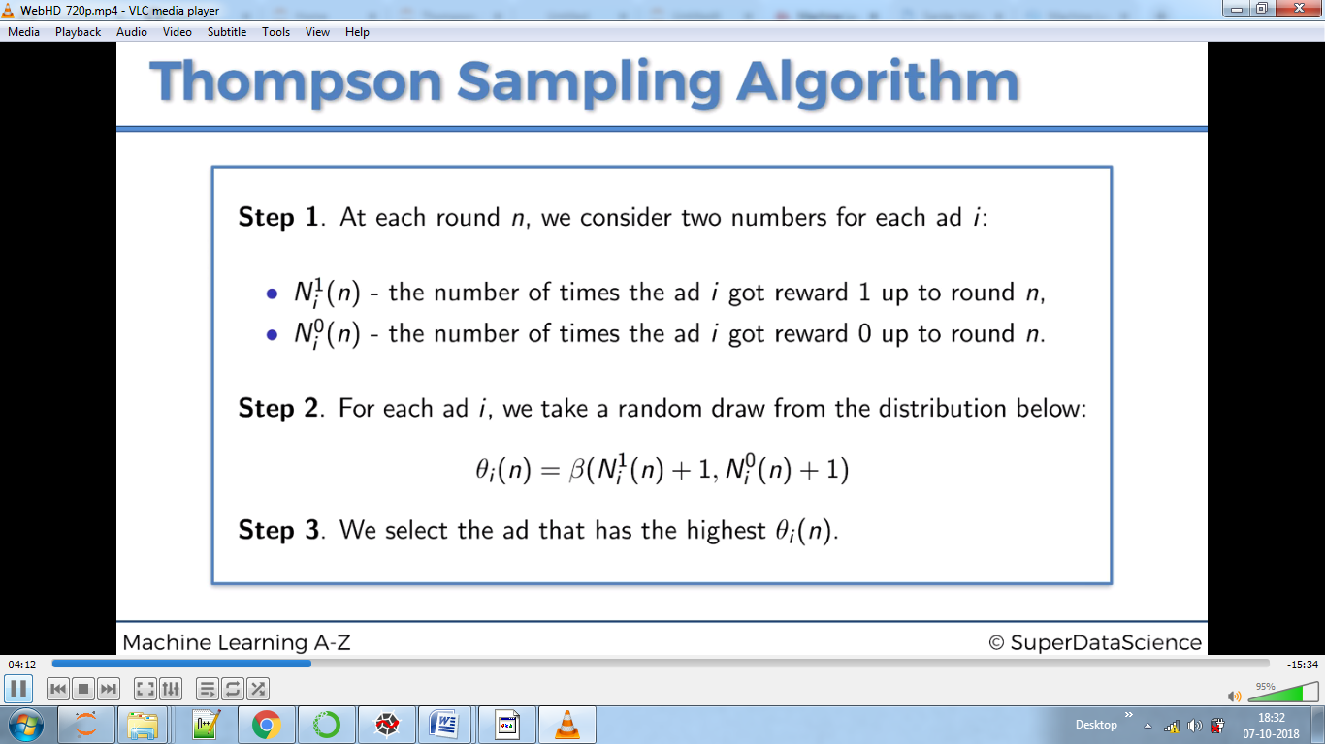

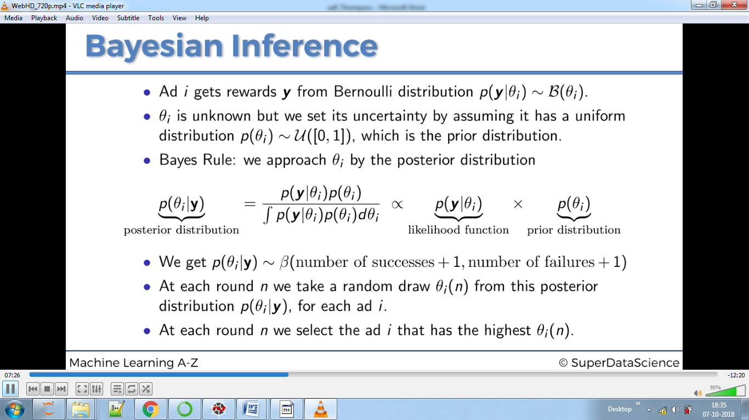

Here we are dealing with probability at each round for all ads and the one having maximum probability is the answer for that round.

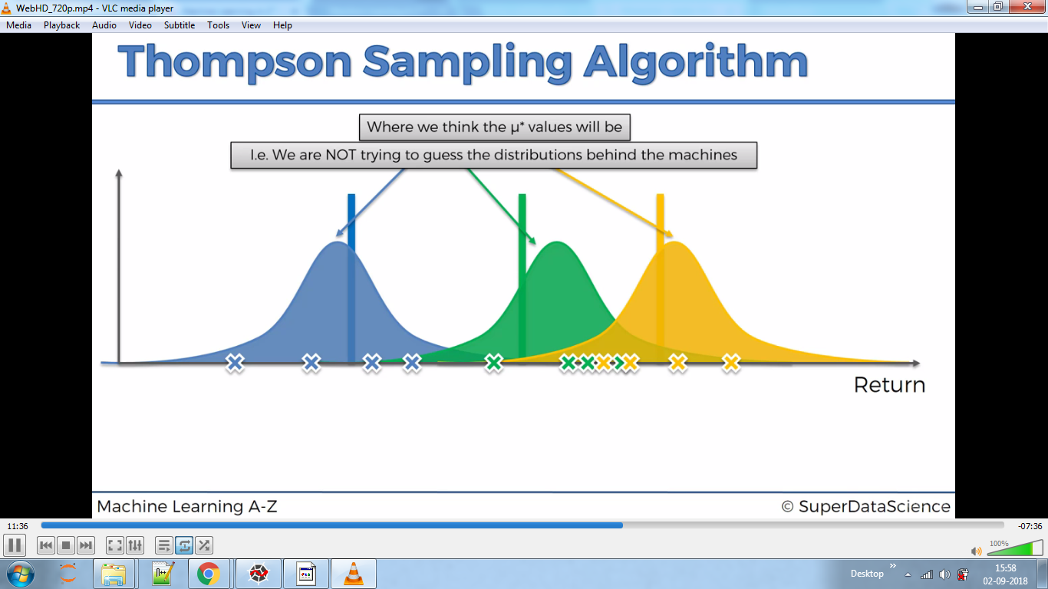

Here we have drawn graphs, where the peak is mu’star predicted by our model. The stick is correct mu’star.

Final iterations:-

Yellow ones are the best.

